**Assignment No:-42**

Name:-Suryawanshi Sangramsingh Sambhaji

Batch: - Delta - DCA (Java) 2024 Date:-5/7/2024

**Q1.Write a Java program to check if an array of integers without 0 and -1.**

package AssignmentNo43;

import java.util.Scanner;

public class ZeroOrNegative {

public static boolean isZero(int a)

{

if(a==0)

return true;

else

return false;

}

public static boolean isNegative(int a)

{

if(a==-1)

return true;

else

return false;

}

public static void main(String[] args)

{

Scanner sc = new Scanner(System.***in***);

System.***out***.print("Enter size : ");

int s = sc.nextInt();

System.***out***.print("Enter array elements : ");

int a[] = new int[s];

for(int i=0;i<a.length;i++)

a[i] = sc.nextInt();

int z=0;

int neg = 0;

for(int i=0;i<a.length;i++)

{

if(*isZero*(a[i]))

z++;

else if(*isNegative*(a[i]))

neg++;

}

if(z>0 && neg >0)

{

System.***out***.println("\nArray contains 0 and -1");

}

else if(z>0 && neg ==0)

{

System.***out***.println("\nArray contains 0 only");

}

else if(neg > 0 && z==0)

{

System.***out***.println("\nArray contains -1 only");

}

else

{

System.***out***.println("\nArray do not contains 0 and -1");

}

}

}

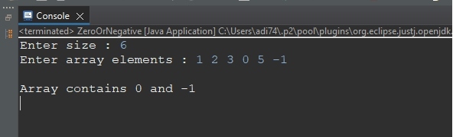

**Q2. Write a Java program to remove the duplicate elements of a given array and print the new length of the array.**

**Sample array: [20, 20, 30, 40, 50, 50, 50]**

**After removing the duplicate elements the program should return 4 as the new length of the array.**

package AssignmentNo43;

import java.util.Scanner;

public class RemoveDuplicate

{

public static int getLength(int a[])

{

int length=0;

for(int i=0;i<a.length;i++)

{

for(int j=i+1;j<a.length;j++)

{

if(a[i] == a[j])

{

a[j] = -1;

}

}

}

System.***out***.print("\nRemoved duplicates :\nArray = ");

for(int i=0;i<a.length;i++)

{

if(a[i] !=-1)

{

System.***out***.print(a[i]+" ");

length++;

}

}

return length;

}

public static void main(String[] args)

{

Scanner sc = new Scanner(System.***in***);

System.***out***.print("Enter size : ");

int s = sc.nextInt();

System.***out***.print("Enter array elements : ");

int a[] = new int[s];

for(int i=0;i<a.length;i++)

a[i] = sc.nextInt();

System.***out***.println("\nNew Length : "+RemoveDuplicate.*getLength*(a));

}

}

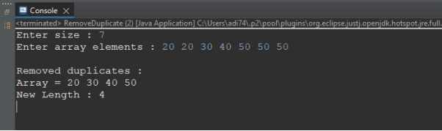

**Q3.Write a Java program to find the sum of the two elements of a given array which is equal to a given integer.**

**Sample array: [1,2,4,5,6]**

**Target value: 6.**

package AssignmentNo43;

import java.util.Scanner;

public class TargetSum

{

public static void getPair(int a[], int t)

{

System.***out***.println("\nSum of two integers whose sum is "+t+" : ");

for(int i=0;i<a.length;i++)

{

for(int j=i+1;j<a.length;j++)

{

if(a[i] + a[j] == t)

{

System.***out***.print("("+a[i]+","+a[j]+") ");

}

}

}

}

public static void main(String[] args)

{

Scanner sc = new Scanner(System.***in***);

System.***out***.print("Enter size : ");

int s = sc.nextInt();

System.***out***.print("Enter array elements : ");

int a[] = new int[s];

for(int i=0;i<a.length;i++)

a[i] = sc.nextInt();

System.***out***.print("Enter target sum : ");

int t = sc.nextInt();

TargetSum.*getPair*(a, t);

}

}

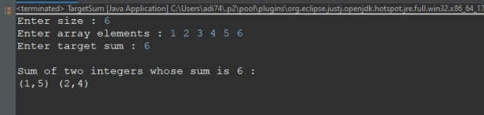

**Q4.Write a Java program to print all the LEADERS in the array.**

**Note: An element is leader if it is greater than all the elements to its right side.**

package AssignmentNo43;

import java.util.Scanner;

public class Leader

{

public static void printLeader(int a[])

{

System.***out***.println("\nLeader element(s) from given array : ");

for(int i=0;i<a.length;i++)

{

int c=0;

for(int j=i+1;j<a.length;j++)

{

if(a[i]<a[j])

{

c++;

break;

}

}

if(c==0)

{

System.***out***.print(a[i]+" ");

}

}

}

public static void main(String[] args)

{

Scanner sc = new Scanner(System.***in***);

System.***out***.print("Enter size : ");

int s = sc.nextInt();

System.***out***.print("Enter array elements : ");

int a[] = new int[s];

for(int i=0;i<a.length;i++)

a[i] = sc.nextInt();

Leader.*printLeader*(a);

}

}

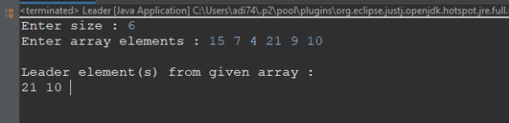

**Q.5Write a Java program to check if an array of integers contains two specified elements 65 and 77.**

package AssignmentNo43;

import java.util.Scanner;

public class Contains65 {

public static boolean is65(int a)

{

if(a==65)

return true;

else

return false;

}

public static boolean is77(int a)

{

if(a==77)

return true;

else

return false;

}

public static void main(String[] args) {

Scanner sc = new Scanner(System.***in***);

System.***out***.print("Enter size : ");

int s = sc.nextInt();

System.***out***.print("Enter array elements : ");

int a[] = new int[s];

for(int i=0;i<a.length;i++)

a[i] = sc.nextInt();

int six=0;

int sev = 0;

for(int i=0;i<a.length;i++)

{

if(*is65*(a[i]))

six++;

else if(*is77*(a[i]))

sev++;

}

if(six>0 && sev >0)

{

System.***out***.println("\nArray contains 65 and 77.");

}

else if(six>0 && sev ==0)

{

System.***out***.println("\nArray contains 65 only.");

}

else if(sev > 0 && six==0)

{

System.***out***.println("\nArray contains 77 only.");

}

else

{

System.***out***.println("\nArray do not contains 65 and 77.");

}

}

}

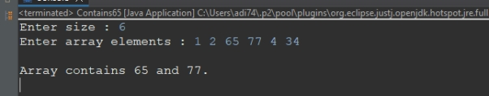

**Q.6Write a Java program to separate even and odd numbers of a given array of integers. Put all even numbers first, and then odd numbers.**

package AssignmentNo43;

import java.util.Arrays;

import java.util.Scanner;

public class EvenFirst

{

public static void sort(int a[])

{

int b[] = new int[a.length];

int ind=0;

for(int i=0;i<a.length;i++)

{

if(a[i]%2==0)

b[ind++] = a[i];

}

for(int i=0;i<a.length;i++)

{

if(a[i]%2!=0)

b[ind++] = a[i];

}

System.***out***.println("\nNew Array :\nb[] = "+Arrays.*toString*(b));

}

public static void main(String[] args)

{

Scanner sc = new Scanner(System.***in***);

System.***out***.print("Enter size : ");

int s = sc.nextInt();

System.***out***.print("Enter array elements : ");

int a[] = new int[s];

for(int i=0;i<a.length;i++)

a[i] = sc.nextInt();

EvenFirst.*sort*(a);

}

}

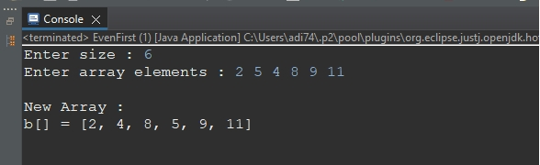

**Q7.Write a java program to find prime number between an array of element.**

package AssignmentNo43;

import java.util.Scanner;

public class PrimeNumbers

{

public static boolean isPrime(int n)

{

int c=0;

for(int i=1;i<=n;i++)

{

if(n%i==0)

c++;

}

if(c==2)

return true;

else

return false;

}

public static void main(String[] args)

{

Scanner sc = new Scanner(System.***in***);

System.***out***.print("Enter size : ");

int s = sc.nextInt();

System.***out***.print("Enter array elements : ");

int a[] = new int[s];

for(int i=0;i<a.length;i++)

a[i] = sc.nextInt();

System.***out***.println("\nPrime numbers from array are : ");

for(int i=0;i<a.length;i++)

{

if(*isPrime*(a[i]))

{

System.***out***.print(a[i]+" ");

}

}

}

}

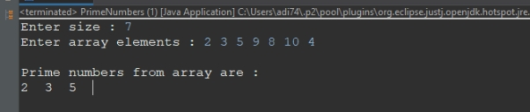

**Q1.Given an array and a number K where K is smaller than the size of the array.**

**Find the K’th smallest element in the given array. Given that all array elements are distinct.**

**Examples:**

**Input: arr[] = {7, 10, 4, 3, 20, 15}, K = 3**

**Output: 7**

package AssignmentNo43;

import java.util.Arrays;

import java.util.Scanner;

public class KthSmallest {

public static void sort(int a[],int k)

{

for(int i=0;i<a.length;i++)

{

for(int j=i+1;j<a.length;j++)

{

if(a[i]>a[j])

{

int t = a[i];

a[i] = a[j];

a[j] = t;

}

}

}

System.***out***.println("\n"+k+"th smallest element is : "+a[k-1]);

}

public static void main(String[] args)

{

Scanner sc = new Scanner(System.***in***);

System.***out***.print("Enter size : ");

int s = sc.nextInt();

System.***out***.print("Enter array elements : ");

int a[] = new int[s];

for(int i=0;i<a.length;i++)

a[i] = sc.nextInt();

System.***out***.print("Enter value of k : ");

int k = sc.nextInt();

KthSmallest.*sort*(a, k);

}

}

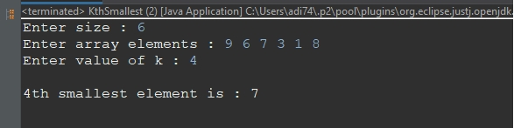

**Q2.Given an array of integers arr[], The task is to find the index of first repeating element in it i.e.**

**the element that occurs more than once and whose index of the first occurrence is the smallest.**

package AssignmentNo43;

import java.util.Scanner;

public class FirstRepeating

{

public static int getInd(int a[])

{

int ind =0;

for(int i=0;i<a.length;i++)

{

for(int j=i+1;j<a.length;j++)

{

if(a[i] == a[j])

{

ind = i;

break;

}

}

if(ind !=0)

break;

}

return ind;

}

public static void main(String[] args)

{

Scanner sc = new Scanner(System.***in***);

System.***out***.print("Enter size : ");

int s = sc.nextInt();

System.***out***.print("Enter array elements : ");

int a[] = new int[s];

for(int i=0;i<a.length;i++)

a[i] = sc.nextInt();

System.***out***.println("\nFirst repeating element index : "+FirstRepeating.*getInd*(a));

}

}

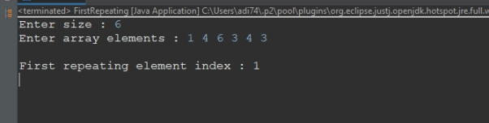

**Q.3 Find the majority element in the array. A majority element in an array A[] of size n is an element**

**that appears more than n/2 times (and hence there is at most one such element).**

**Examples :**

**Input : {3, 3, 4, 2, 4, 4, 2, 4, 4}**

**Output : 4**

**Explanation: The frequency of 4 is 5 which is greater than the half of the size of the array size.**

package AssignmentNo43;

import java.util.Scanner;

public class MajorityElement

{

public static void element(int a[])

{

System.***out***.println("\nMajority element : ");

for(int i=0;i<a.length;i++)

{

int c=1;

for(int j=i+1;j<a.length;j++)

{

if(a[i] == a[j])

c++;

}

if(c > (a.length/2))

{

System.***out***.print(a[i]+" ");

break;

}

}

}

public static void main(String[] args)

{

Scanner sc = new Scanner(System.***in***);

System.***out***.print("Enter size : ");

int s = sc.nextInt();

System.***out***.print("Enter array elements : ");

int a[] = new int[s];

for(int i=0;i<a.length;i++)

a[i] = sc.nextInt();

MajorityElement.*element*(a);

}

}

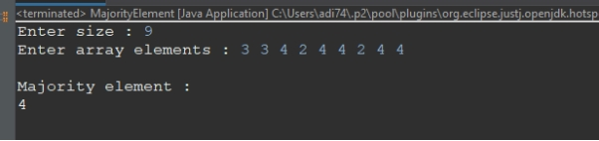

**Q4.Given an array of N integers, and a number sum, the task is to find the number of pairs of integers in the array whose sum is equal to sum.**

**Examples:**

**Input: arr[] = {1, 5, 7, -1}, sum = 6**

**Output: 2**

package AssignmentNo43;

import java.util.Scanner;

public class PairsCount

{

public static void getPair(int a[], int t)

{

int c=0;

for(int i=0;i<a.length;i++)

{

for(int j=i+1;j<a.length;j++)

{

if(a[i] + a[j] == t)

{

c++;

}

}

}

System.***out***.println("\nOutput : "+c);

}

public static void main(String[] args)

{

Scanner sc = new Scanner(System.***in***);

System.***out***.print("Enter size : ");

int s = sc.nextInt();

System.***out***.print("Enter array elements : ");

int a[] = new int[s];

for(int i=0;i<a.length;i++)

a[i] = sc.nextInt();

System.***out***.print("Enter target sum : ");

int t = sc.nextInt();

PairsCount.*getPair*(a, t);

}

}

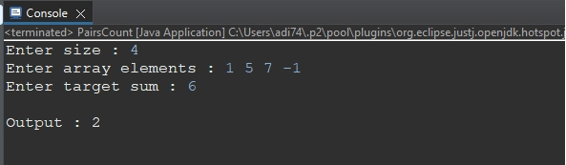

**Q5.Given an array and a value, find if there is a triplet in array whose sum is equal to the given value.**

**If there is such a triplet present in array, then print the triplet and return true. Else return false.**

**Examples:**

**Input: array = {12, 3, 4, 1, 6, 9}, sum = 24;**

**Output: 12, 3, 9**

package AssignmentNo43;

import java.util.Scanner;

public class TripletSum

{

public static void getTriplet(int a[],int t)

{

System.***out***.println("\nOutput : ");

for(int i=0;i<a.length;i++)

{

for(int j=i+1;j<a.length;j++)

{

for(int k =j+1;k<a.length;k++)

{

if(a[i]+a[j]+a[k] == t)

{

System.***out***.println(a[i]+" "+a[j]+" "+a[k]);

break;

}

}

}

}

}

public static void main(String[] args)

{

Scanner sc = new Scanner(System.***in***);

System.***out***.print("Enter size : ");

int s = sc.nextInt();

System.***out***.print("Enter array elements : ");

int a[] = new int[s];

for(int i=0;i<a.length;i++)

a[i] = sc.nextInt();

System.***out***.print("Enter target sum : ");

int t = sc.nextInt();

TripletSum.*getTriplet*(a, t);

}

}

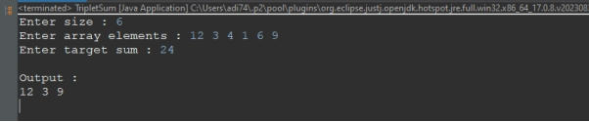

**Q3.a[]={10,20,30,40,50}**

**b[]={1,2,3,4,5}**

**output array=c[]={10,5,20,4,30,3,40,2,50,1}**

package AssignmentNo43;

import java.util.Arrays;

import java.util.Scanner;

public class AlternateMerge

{

public static void merge(int a[],int b[])

{

int c[] = new int[a.length+b.length];

int x=0,y=b.length-1;

for(int i=0;i<c.length;i++)

{

if(i%2==0)

{

c[i] = a[x++];

}

else

{

c[i] = b[y--];

}

}

System.***out***.println("\nMerged array : "+Arrays.*toString*(c));

}

public static void main(String[] args)

{

Scanner sc = new Scanner(System.***in***);

System.***out***.print("Enter size : ");

int s = sc.nextInt();

System.***out***.print("Enter frist array elements : ");

int a[] = new int[s];

for(int i=0;i<a.length;i++)

a[i] = sc.nextInt();

System.***out***.print("\nEnter frist array elements : ");

int b[] = new int[s];

for(int i=0;i<a.length;i++)

b[i] = sc.nextInt();

AlternateMerge.*merge*(a, b);

}

}

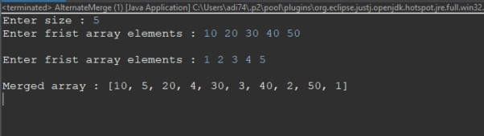

**Q4.Wap sort half array in accending and half in decending order**

**input= int [] a={9,1,3,5,6,11,22,66,10,19}.**

**output={1,3,5,6,9,10,66,22,19,11,10},**

package AssignmentNo43;

import java.util.Arrays;

import java.util.Scanner;

public class HalfAscending

{

public static void sort(int a[])

{

Arrays.*sort*(a);

for(int i=a.length/2;i<a.length;i++)

{

for(int j = i+1;j<a.length;j++)

{

if(a[i] < a[j])

{

int t = a[i];

a[i] = a[j];

a[j] = t;

}

}

}

System.***out***.println("\nNew Array : "+Arrays.*toString*(a));

}

public static void main(String[] args)

{

Scanner sc = new Scanner(System.***in***);

System.***out***.print("Enter size : ");

int s = sc.nextInt();

System.***out***.print("Enter array elements : ");

int a[] = new int[s];

for(int i=0;i<a.length;i++)

a[i] = sc.nextInt();

HalfAscending.*sort*(a);

}

}

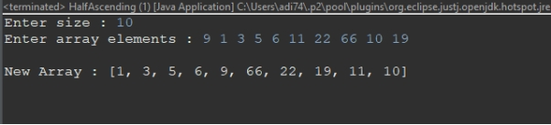

**Q5.Wap input an array now delete element from array, element is taken from user.**

package AssignmentNo43;

import java.util.Scanner;

public class Delete {

public static void delete(int a[],int d)

{

int ind=-1;

for(int i=0;i<a.length;i++)

{

if(a[i] == d)

ind = i;

}

for(int i=ind;i<a.length-1;i++)

{

a[i] = a[i+1];

}

System.***out***.println("\nElement deleted..");

for(int i=0;i<a.length-1;i++)

{

System.***out***.print(a[i]+" ");

}

}

public static void main(String[] args)

{

Scanner sc = new Scanner(System.***in***);

System.***out***.print("Enter size : ");

int s = sc.nextInt();

System.***out***.print("Enter frist array elements : ");

int a[] = new int[s];

for(int i=0;i<a.length;i++)

a[i] = sc.nextInt();

System.***out***.println("Enter element to delete : ");

int d = sc.nextInt();

Delete.*delete*(a, d);

}

}

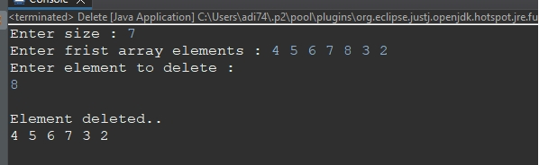

**Q5.Wap input an array now delete element from array, position is taken from user.**

package AssignmentNo43;

import java.util.Scanner;

public class DeletePosition {

public static void delete(int a[],int p)

{

int ind=p-1;

for(int i=ind;i<a.length-1;i++)

{

a[i] = a[i+1];

}

System.***out***.print("\nElement deleted at given position...\na[] = ");

for(int i=0;i<a.length-1;i++)

{

System.***out***.print(a[i]+" ");

}

}

public static void main(String[] args)

{

Scanner sc = new Scanner(System.***in***);

System.***out***.print("Enter size : ");

int s = sc.nextInt();

System.***out***.print("Enter frist array elements : ");

int a[] = new int[s];

for(int i=0;i<a.length;i++)

a[i] = sc.nextInt();

System.***out***.println("Enter position to delete : ");

int p = sc.nextInt();

*delete*(a, p);

}

}

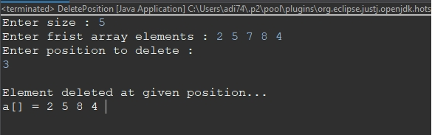

**Q6.Wap input an array and rotate it in anti clock wise by any no give by user.**

package AssignmentNo43;

import java.util.Arrays;

import java.util.Scanner;

public class AntiClock

{

public static void rotate(int a[],int n)

{

for(int i=1;i<=n;i++)

{

int t = a[0];

for(int j=0;j<a.length-1;j++)

{

a[j] = a[j+1];

}

a[a.length-1] = t;

}

System.***out***.println("\nRotated array : "+Arrays.*toString*(a));

}

public static void main(String[] args)

{

Scanner sc = new Scanner(System.***in***);

System.***out***.print("Enter size : ");

int s = sc.nextInt();

System.***out***.print("Enter frist array elements : ");

int a[] = new int[s];

for(int i=0;i<a.length;i++)

a[i] = sc.nextInt();

System.***out***.print("Enter number of rotations : ");

int n = sc.nextInt();

AntiClock.*rotate*(a, n);

}

}

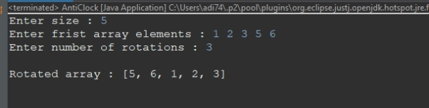

**Q7.Wap input an array and rotate it in clock wise by any no give by user.**

package AssignmentNo43;

import java.util.Arrays;

import java.util.Scanner;

public class ClockWise

{

public static void rotate(int a[],int n)

{

for(int i=1;i<=n;i++)

{

int t = a[a.length-1];

for(int j=a.length-1;j>0;j--)

{

a[j] = a[j-1];

}

a[0] = t;

}

System.***out***.println("\nRotated array : "+Arrays.*toString*(a));

}

public static void main(String[] args)

{

Scanner sc = new Scanner(System.***in***);

System.***out***.print("Enter size : ");

int s = sc.nextInt();

System.***out***.print("Enter frist array elements : ");

int a[] = new int[s];

for(int i=0;i<a.length;i++)

a[i] = sc.nextInt();

System.***out***.print("Enter number of rotations : ");

int n = sc.nextInt();

ClockWise.*rotate*(a, n);

}

}

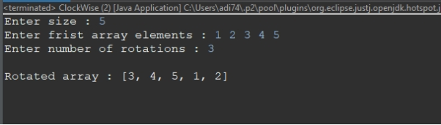

**Q8.Wap input an array and delete all duplicate element from array.**

package AssignmentNo43;

import java.util.Scanner;

public class DeleteDuplicate

{

public static void remove(int a[])

{

for(int i=0;i<a.length;i++)

{

for(int j=i+1;j<a.length;j++)

{

if(a[i] == a[j])

a[j] =-1;

}

}

System.***out***.println("\nRemoved duplicate elements : ");

for(int i=0;i<a.length;i++)

{

if(a[i]!=-1)

System.***out***.print(a[i]+" ");

}

}

public static void main(String[] args)

{

Scanner sc = new Scanner(System.***in***);

System.***out***.print("Enter size : ");

int s = sc.nextInt();

System.***out***.print("Enter frist array elements : ");

int a[] = new int[s];

for(int i=0;i<a.length;i++)

a[i] = sc.nextInt();

DeleteDuplicate.*remove*(a);

}

}

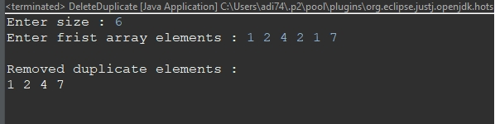

**Q9. Write a Java program to find max number in an array.**

package AssignmentNo43;

import java.util.Scanner;

public class MaxElement

{

public static void main(String[] args)

{

Scanner sc = new Scanner(System.***in***);

System.***out***.print("Enter size : ");

int s = sc.nextInt();

System.***out***.print("Enter frist array elements : ");

int a[] = new int[s];

for(int i=0;i<a.length;i++)

a[i] = sc.nextInt();

int max=0;

for(int i=0;i<a.length;i++)

{

if(a[i] > max)

max = a[i];

}

System.***out***.println("\nMax element : "+max);

}

}

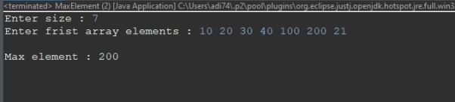

**Q10.Wap input an array now insert any element at any position ,**

**element and position is taken by user.**

package AssignmentNo43;

import java.util.Arrays;

import java.util.Scanner;

public class Insert {

public static void insert(int a[], int ele, int p)

{

int ind =p-1;

for(int i=a.length-1;i>ind-1;i--)

{

a[i] = a[i-1];

}

a[ind] = ele;

System.***out***.println("\nAfter insertion : ");

System.***out***.println(Arrays.*toString*(a));

}

public static void main(String[] args)

{

Scanner sc = new Scanner(System.***in***);

System.***out***.print("Enter size : ");

int s = sc.nextInt();

System.***out***.print("Enter frist array elements : ");

int a[] = new int[s+1];

for(int i=0;i<a.length-1;i++)

a[i] = sc.nextInt();

System.***out***.print("Enter element to insert : ");

int ele = sc.nextInt();

System.***out***.print("Enter position : ");

int p = sc.nextInt();

Insert.*insert*(a, ele, p);

}

}

